Open Games Workshop

SS 25

Game Design Document



Gruppe:

Michael Nock, Martin Steinmayer, Christian Mulser, Thomas Putzer, Potap Model, Roberto Blanco Romero

# Overview

## Core Idea

Blueprint X is a fast‑paced 2D platform‑fighter in which up to four local players attempt to knock each other off the battle arena with their attacks, trigger interactive stage elements, and clash in the cinematic mini‑games. Victory is earned by depleting opponents’ stocks rather than their hit‑points, encouraging aggressive movement and creative use of the environment.

Core Features

Genre & Target Audience

The game is a platform fighter where the goal is to knock opponents off the arena. This subgenre is less focused on skill and is more accessible, making it enjoyable for both casual and experienced gamers. Blueprint X combines classic knockback mechanics—where lower health means more pushback—with a traditional health bar system: if your health hits zero, you're eliminated. This hybrid approach draws inspiration not only from *Super Smash Bros.* and *Brawlhalla*, but also from traditional fighters like *Mortal Kombat* and *Street Fighter*. Blueprint X stands out through its use of interactive arenas and cinematic dual mini games. Given that the game contains some level of violence, it is aimed at a target audience of individuals aged 13 and older, specifically teenagers and young adults.

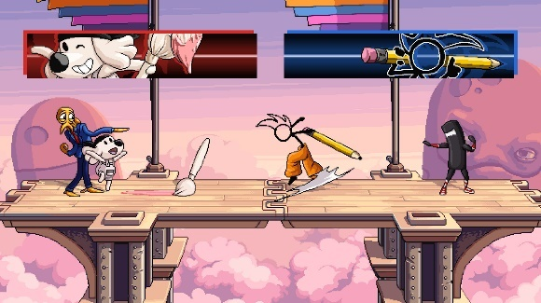

Platform Fighter Examples

# Detailed Design

Core Mechanics

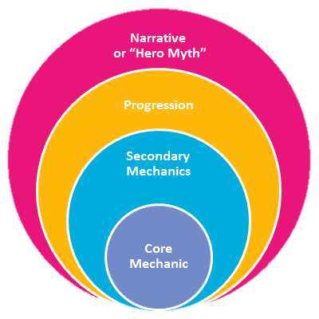

Multiplayer Combat

Beat other Players

Minigame & Interactive Arena

Imaginative Fighting Scenario

Game Rules

Destroy Opponent(s)

Players deal damage using attacks, which both reduce health and apply knockback. The lower an opponent's health, the further they fly. The goal is to eliminate all other players.

Stay in the Arena

If the player falls off the fighting stage or gets kicked out of visible bounds, they lose one life. If the player loses three lives, they lose.

Game Mechanics

Platform Triggers

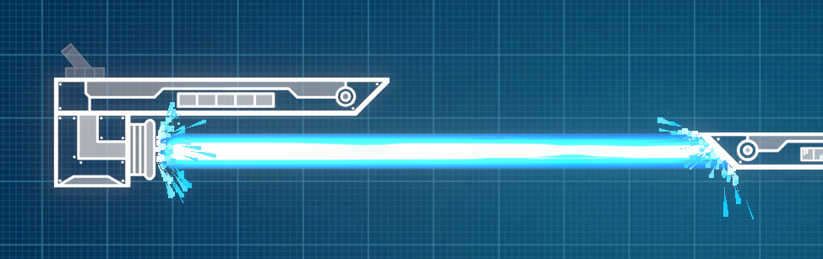

Activated Laser

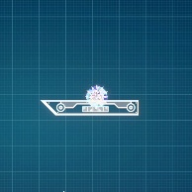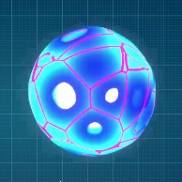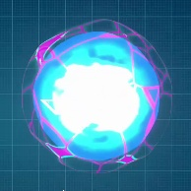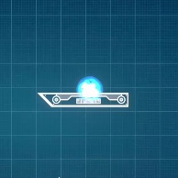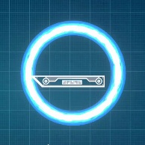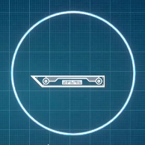

Exploding Bomb

Minigame (Quick Time Event)

In special circumstances, two players may trigger a special quick-time event that requires them to play a minigame.

Final clash

If a player has one life left, receiving a finishing blow (a heavy attack or an ultimate that would push the player off the stage), will trigger the minigame. If the player wins in the final clash, they become an extra life and can continue playing. If they lose, they also lose their last life and trigger a special finisher animation for the other player. If it’s a draw between both players, the player that was on his last life will respawn with zero health, meaning that they are also more prone to be eliminated.

Ultimate Clash

If a player’s ultimate attack collides with the opponent’s ultimate attack, the player and the opponent will play the minigame, where the loser will be knocked off-stage and lose a guard point.

Technical Design

Controls

Blueprint X supports both keyboard and gamepad controls. Players can rebind keys and switch control schemes at any time.

Default Inputs

|  |  |  |
| --- | --- | --- |
| Action | Keyboard | Gamepad |
| Move | WASD | Left Stick |
| Jump | Space | A |
| Dash | Left Shift | Left Trigger (L1) |
| Quick Attack | J | X |
| Heavy Attack | K | Y |
| Ultimate Attack | L | Left & Right Bumper (L2 + R2) |
| Block | I | Right Bumper (R2) |
| Interact | E | B |

Interaction System

Players can interact with the environment using a single Interact button. This includes:

* Picking up and throwing items (Bomb)
* Activating platform triggers (through levers)

All interactive elements follow the same rule: press the “Interact” button near the object will either equip (grab a bomb) or trigger it (throw a bomb, activate a special platform).

Aesthetics

Setting & Style

The game itself doesn’t have a specific story or set of characters, mainly because it aims towards a more abstract and imaginative setting: Hand-drawn stickmen fighting on a blueprint plan.

UI Style

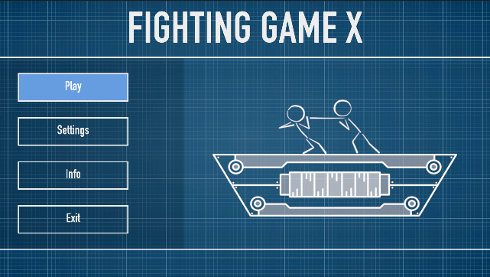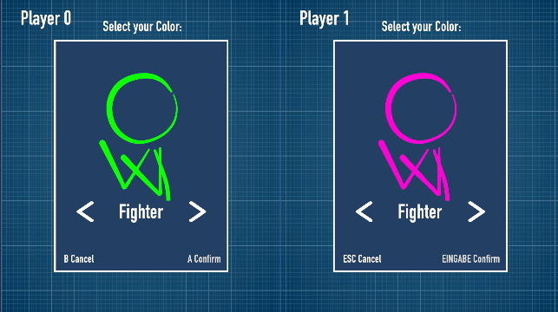

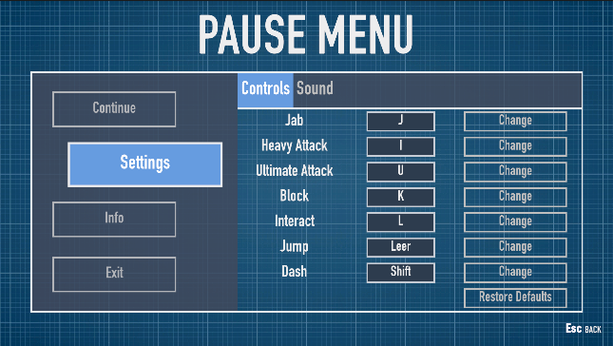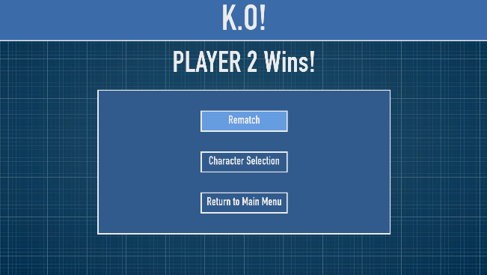

Inspiration

Sketches

Possible Character Classes

Arena Concepts

Minigame Idea

Bibliography

* https://www.pinterest.com/pin/jet-engine-outline-style-vector-blueprint--328973947781235125/
* https://loooop.studio/blog/how-la-linea-made-waves-with-one-line-animation
* https://www.youtube.com/watch?v=6MTY2U4ZhIA
* https://de.vexels.com/png-svg/preview/189928/stickman-vektor-pose